PSAC BLAST 11/11/24
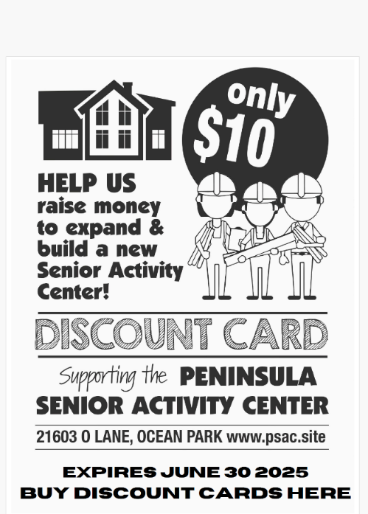
The PSAC WEBSITE Peninsula Senior Activity Center (psac.site)
Announcements:
- Game night is temporarily cancelled until further notice
- WE URGENTLY NEED HELP GETTING LAST YEAR’S LEFTOVERS HAULED TO GOODWILL OR OTHER DONATION POINTS. PLEASE GRAB A LOAD THE NEXT TIME YOU ARE HEADING TO WARRENTON OR LONGVIEW.
- We are now accepting donations with the following exceptions:
  - Anything that is missing parts, cords, or doesn't work.
  - BBQ's. large
  - Bed frames, Mattresses, Bedding that is stained or torn
  - Books (The exceptions are exercise, outdoor recreation, gardening, craft, art, cooking.)
  - Cassette tapes, VHS tapes
  - Chemicals that are toxic or poisonous
  - Clothing that is stained or torn
  - Computers, Printers, Televisions, older tube style
  - Exercise equipment, large
  - Furniture (The exceptions are small chairs, small end or bedside tables, small bookcases, and shelving units.)
  - Medical equipment such as needles, insulin dosages, C PAP supplies, hearing aid batteries.
- 11/14 and 12/5 Medicare Workshops, 12-3pm presented by James Hamilton with Davidson’s Insurance
- It is that time of year!! Check out the Advent Calendar (below) to help our neighbors.
- Discount Cards now for sale at PSAC, Kraken Kafe (check out their new menu!!!), Romeo’s Pad, Purely Shell Fiber Arts, and Bay Avenue Gallery and the Pie Lady
DATE | Nov Events: (call 360-665-3999 to RSVP)
Nov 11th | Veteran’s Day Lunch. Noon. Moose Lodge. This free lunch is only for Veterans!!! Pot roast, potatoes, carrots, onions, salad, roll & butter, pie. Please RSVP at 360-214-8213.
Nov 13th | Senior Information and Assistance Office. 9 am to Noon. Walk-ins or call 360-642-3634 for an appointment.
Nov 13th | Timberland Library Book Mobile. 10:30 – 11:30 am.
Nov 14th | Medicare Workshops, 12-3pm presented by James Hamilton with Davidson’s Insurance
Nov 19th | Basic Trouble Shooting & Digital Hygiene, with Lynn Westfall. The “Modem Lisa” 1 pm. $30.
Nov 20th | Senior Information and Assistance Office. 9 am to Noon. Walk-ins or call 360-642-3634 for an appointment.
Nov 21st | PSAC Thanksgiving Dinner!!! Turkey and all the regular sides! $13 per person. RSVP a must!!!
Nov 23rd | Breakfast
Nov 23rd | Basket Guild 11:00 – 2:00
Nov 26th | Bingo!!! 1 pm. $5. Come win a choice of desserts to take home!! Dessert and drinks will be served during Bingo
Nov 27th | Senior Information and Assistance Office. 9 am to Noon. Walk-ins or call 360-642-3634 for an appointment.
Nov 28th | Annual Thanksgiving Day Potluck!!! 1 pm. We provide the turkey and gravy and you bring your favorite potluck dishes!!!! You don’t have to stay at home and just do all that cooking for only one or two of you!!! Come dine with all your PSAC friends!
Nov 28th /30th | PSAC Closed (except for Potluck! At 1:00)
 | December Events: (call 360-665-3999 to RSVP)
Dec 1st | Grief Counseling, w/ Robin from Harbors Home Health. 2 pm
Dec 5th | Medicare Workshops, 12-3pm presented by James Hamilton with Davidson’s Insurance
Dec 12th – 25th | Cruise
Dec, 14th | Breakfast - Gingerbread pancakes.$9
Dec 19th | Christmas dinner.
Dec 24th | No Bingo
Dec. 25th | PSAC Closed for regular activities except Christmas Potluck 1:00
Dec. 28th | Breakfast TBD
Dec 31st | New Year’s Eve - Prime Rib Dinner
 | January Events: (call 360-665-3999 to RSVP)
Jan 1st | PSAC Closed
Jan 11th | Breakfast
Jan 16th | Dinner, ribs.
Jan 25th | Breakfast
Jan 25th | Basket Guild 11:00 – 2:00
Jan 29th | Chinese New Year Dinner Buffet, 5:00 p.m.

